Table Of Contents
Use Case Model 2
UC01: Use Case Model 2
Customer 2
UC01-1: User Management 4
Login 4
Register with Book Shop 6
UC01-2: Select Books 9
Browse Book Catalogue 9
Locate Book by Title or Author 10
Request UnListed Book 12
UC01-3: Manage Order 14
Add title to Cart 14
Pay for Order 16
Remove Item from Cart 17
View Cart 18
UC01-4: Order Status 20
Cancel Order 20
Enquire on Order Status 22

Table Of Figures
Figure 1 : Overview 2
Figure 2 : User Management 4
Figure 3 : Implementation 5
Figure 4 : Login 6
Figure 5 : Implementation 7
Figure 6 : Register 8
Figure 7 : Book Selection 9
Figure 8 : Browse Catalogue 10
Figure 9 : Implementation 10
Figure 10 : Implementation 11
Figure 11 : Locate Book 12
Figure 12 : Implementation 12
Figure 13 : Request Book 13
Figure 14 : User Orders 14
Figure 15 : Add to Cart 15
Figure 16 : Implementation 15
Figure 17 : Implementation 16
Figure 18 : Pay for Order 17
Figure 19 : Implementation 18
Figure 20 : Remove Item 18
Figure 21 : Implementation 19
Figure 22 : View Cart 19
Figure 23 : Review Order Status 20
Figure 24 : Cancel Order 21
Figure 25 : Implementation 21
Figure 26 : Implementation 22
Figure 27 : Order Status 23

Use Case Model
The Use Case Model describes the proposed functionality of the new system. A Use Case represents a discrete unit of interaction between a user (human or machine) and the system. A Use Case is a single unit of meaningful work; for example creating a train, modifying a train and creating orders are all Use Cases.
Each Use Case has a description which describes the functionality that will be built in the proposed system. A Use Case may 'include' another Use Case's functionality or 'extend' another Use Case with its own behaviour.
Use Cases are typically related to 'actors'. An actor is a human or machine entity that interacts with the system to perform meaningful work.

UC01: Use Case Model

A Use Case model describes the functionality of the system - what the system will do for the user in order to get some useful work done. It is typically made up of Use Cases, which describe the functional units of the system and Actors, which describes the users (including other computer systems).

This diagram provides an overview of the Customer's available activities in the proposed system - from logging on to browsing the book store, selecting items and making purchases.

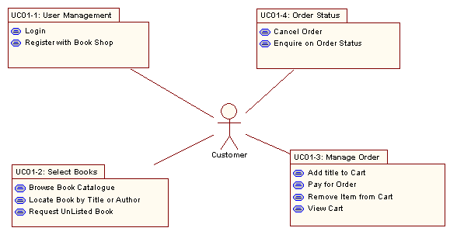
Figure 1 : Overview

Customer
Actor: The internet customer. This includes all users of the on-line book store who register with the system. Customers will be able to browse, select and buy books on-line.

Requirements
- Proposed. Internet connection.

Connections
- Uses usecase Login. A customer uses the login use case to access the book store
- Uses usecase Register with Book Shop. A customer will use the Register use case to register themselves with the book store if they are not already a member
- Uses usecase Browse Book Catalogue. A customer will use the Browse Book Catalogue use case to browse through the books on sale and make selections
- Uses usecase Locate Book by Title or Author. The customer will be able to search for a specific title
- Uses usecase Request UnListed Book. A customer may request an unlisted book as a special order
- Uses usecase Add title to Cart. A customer may add a selected title to their shopping cart
- Uses usecase Remove Item from Cart. A customer will use this use case to remove a previously added item from their shopping cart
- Uses usecase View Cart. A customer can view the contents of their cart
- Uses usecase Pay for Order. A customer can pay for an order using this use case link
- Uses usecase Enquire on Order Status. A customer may enquire on their order status
- Uses usecase Cancel Order. Under some circumstances a customer may cancel an order
- Uses package UC01-2: Select Books
- Uses package UC01-1: User Management
- Uses package UC01-4: Order Status
- Uses package UC01-3: Manage Order
- Login message to sequence Login Screen. Customer access the login screen in their browser
- Enter details message to sequence Register Screen. The customer enters their personal details as part of the register process
- Getcartdetails message to sequence Cart Page
- Cartdetails message from sequence Cart
- Additem message to sequence Controller
- Unnamed message to sequence Controller
- Itemadded message from sequence CartItem
- Browse message to sequence Browse Screen. The customer will access the browse screen and scroll thru lists of books
- Requestcart message to sequence Cart Details
- Display message from sequence Cart Details
- Filter criteria message to sequence Browsing Screen. The customer enters filter criteria
- Refresh message to sequence Browsing Screen. The customer may refresh the display
- Findorder message to sequence Order Details
- [orderdetails] message from sequence Order
- Cancelorder message to sequence Order Details
- Result message from sequence Order Manager
- Getorderdetails message to sequence Order Details
- Viewresults message from sequence Order Details
- Requestbook message to sequence Book request
- [result] message from sequence Book request
- Enter payment details message to sequence Payment Screen
- [result] message from sequence Payment Screen
- Delete item message to sequence Cart Details
- Display message from sequence Cart Details

UC01-1: User Management

The customer must be able to login to the on-line system. If not already registered, they will be prompted to register with the system.

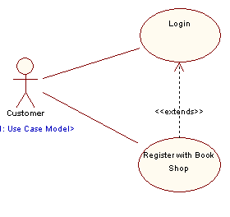
Figure 2 : User Management

Login
Use Case: The on-line book store customers need to be able to log on to the system. The connection to the system will be over secure HTTP (SSL)

Requirements
- Proposed. Login to system.
- Proposed. Encrypt user details over HTTPS.
- Proposed. Logout of system.
- Proposed. Go to register screen for non-registered users.

Connections
- Used by actor Customer. A customer uses the login use case to access the book store
- Extends link from usecase Register with Book Shop. The Register use case extends the Login use case in situations where the user does not have an account with the book store. Once registered they may complete the login use case
- Realisation link to requirement 1.01 Log on to the website
- Realisation link from component Business Logic
- Realisation link from component ASP Pages
- Realisation link from screen Login

Scenarios
Login {Basic Path}.
1. User access the Login page;
2. User enters login name and password
3. System validates entered data;
4. On success user is taken to book store;
5. On fail user may try again or go to register page;

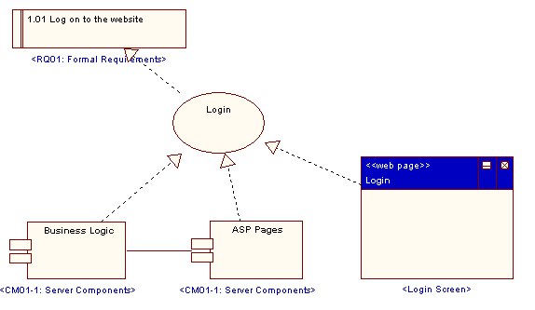
Shows the requirements that the Login Use Case realises, and the components and user interface elements that realize this Use Case.
Figure 3 : Implementation

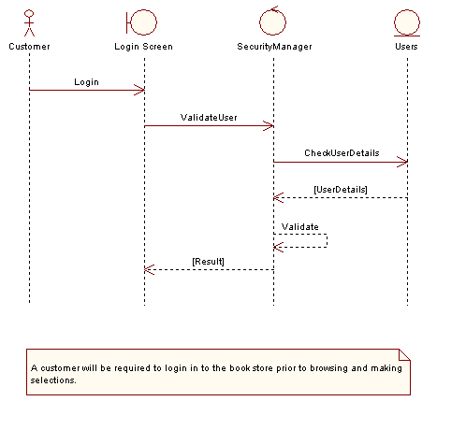
Illustrates the flow of events that take place when a user logs into the system.
Figure 4 : Login

Register with Book Shop
Use Case: A user who is not registered will need to enter their details and get an account with the book shop. This will normally include details such as name, email, address, phone, preferences & etc.

Requirements
- Proposed. Register with book shop. The customer may register with the book shop
- Proposed. Save preferences.
- Proposed. Collect email and contact info.

Constraints
- Proposed Post-condition . User registered.
- Proposed Pre-condition . User not already registered. The user must not be already registered with the system

Connections
- Used by actor Customer. A customer will use the Register use case to register themselves with the book store if they are not already a member
- Extends link to usecase Login. The Register use case extends the Login use case in situations where the user does not have an account with the book store. Once registered they may complete the login use case
- Realisation link to requirement 1.02 Register a new user with the system
- Realisation link from package LM01-1: Customer Domain
- Realisation link from screen Register as New User

Scenarios
Register {Basic Path}.
1. User enters preferred user login name, personal details and password
2. System validates name not in use
3. On success user is registered with book store
4. On failure user is promted to try another login name

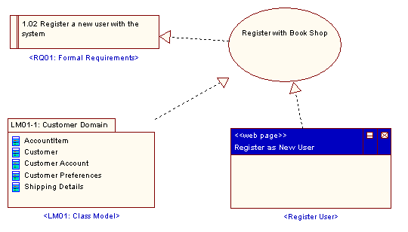
Details of the requirements met by the Register with Book Shop use case and the use case implementors.
Figure 5 : Implementation

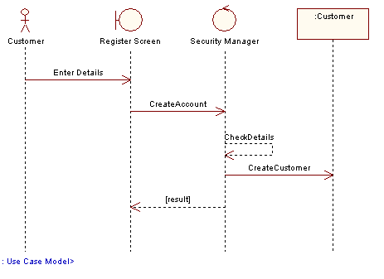
Illustrates the flow of events that take place when a user registers with the system.
Figure 6 : Register

UC01-2: Select Books

This diagram illustrates the use cases which support searching for a book and browsing the resultant recordset. The customer can enter browse criteria and scroll thru the results. If they so wish, the user may select an item for addition to their current shopping cart.

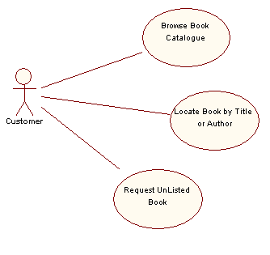
Figure 7 : Book Selection

Browse Book Catalogue
Use Case: The customer can browse the current book catalogue on-line. This should detail both the book details and the stock details for books. The user should be able to filter by book titile, author, book category.

Requirements
- Proposed. Display a filtered set of books.
- Proposed. Scroll thru list.
- Proposed. Page to next set of results.
- Proposed. Add item to cart.
- Proposed. Get more information on an item.

Connections
- Used by actor Customer. A customer will use the Browse Book Catalogue use case to browse through the books on sale and make selections
- Realisation link to requirement 2.01 Browse a catalogue of available book titles

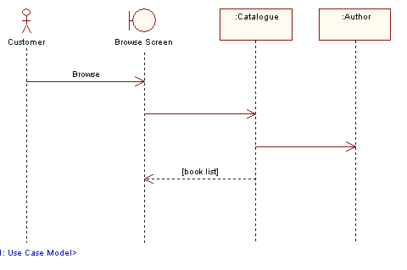
Illustrates the workflow associated with browsing the book store catalogue
Figure 8 : Browse Catalogue

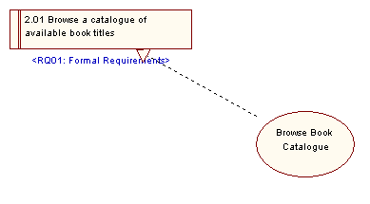
Details the requirements met by this use case
Figure 9 : Implementation

Locate Book by Title or Author
Use Case: The user enters some filter criteria such as book title or author. This limits the returned set of books to those that match the supplied filter. Wild cards such as '*' and '?' should be supported.

Requirements
- Proposed. Enter search criteria for author.
- Proposed. Enter book title search criteria.
- Proposed. Refresh query.

Connections
- Used by actor Customer. The customer will be able to search for a specific title
- Realisation link to requirement 2.02 Search for a book by title or author

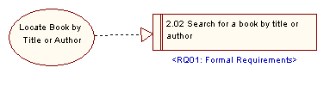
Provides a link from the use case to the requirements implemented.
Figure 10 : Implementation

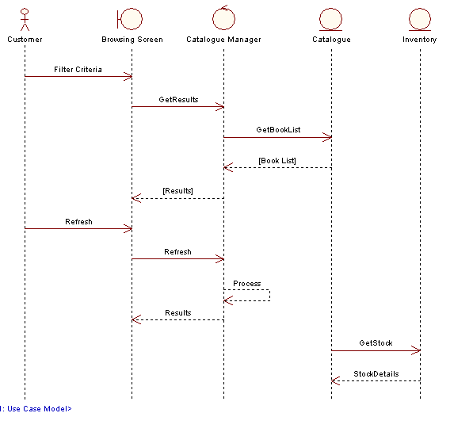
Details the flow of events when a user searches for a book on-line. The system will return both catalogue and inventory details for the items selected.
Figure 11 : Locate Book

Request UnListed Book
Use Case: If the user cannot find a book in the current category, they should be able to place a special request. This should include details such as Author, Publisher, Title, ISBN and any other helpful information.

Requirements
- Proposed. Enter a request for a book not in the catalogue.

Connections
- Used by actor Customer. A customer may request an unlisted book as a special order
- Realisation link to requirement 2.03 Place a request for an un-catalogued book

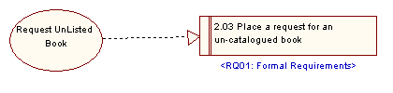
Traceability for the Request Unlisted Book use case
Figure 12 : Implementation

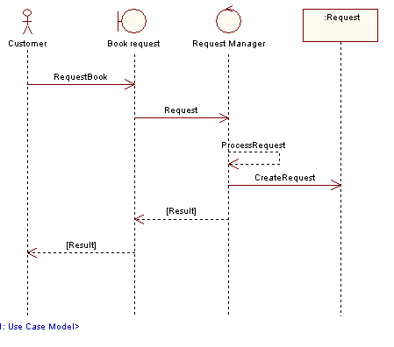
Shows the Request Book workflow
Figure 13 : Request Book

UC01-3: Manage Order

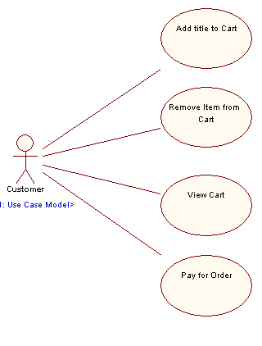
Figure 14 : User Orders

Add title to Cart
Use Case: This use case allows a user to add a book title to their on-line shopping cart. A user first uses the Select Book use case to find the required item - then this use case to temporarily store the title for later purchase.

Connections
- Used by actor Customer. A customer may add a selected title to their shopping cart
- Realisation link to requirement 3.01 Add titles to a shopping cart

Scenarios
Add title to cart {Basic Path}.
1. User has searched for and selected a title;
2. User highlights the required item in the selection list;
3. User pressess an 'Add to Cart' button to add the item to their shopping cart.
4. The selected title is added to the cart

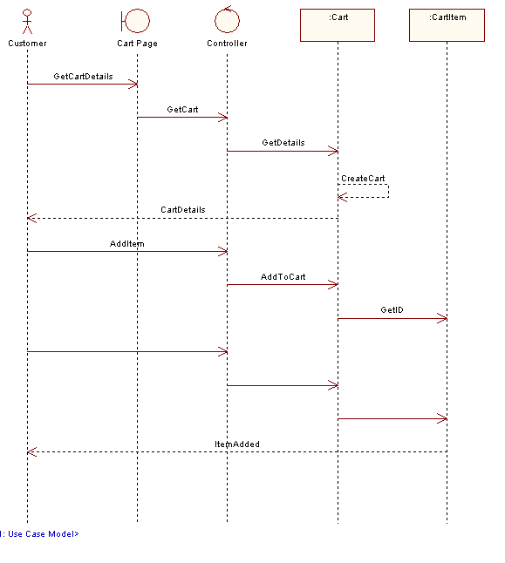
Workflow associated with adding an item to the on-line shopping cart
Figure 15 : Add to Cart

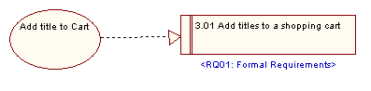
Add title to cart implmentation details
Figure 16 : Implementation

Pay for Order
Use Case: Once a user has created their shopping cart and made their final selection, they may pay for their order and enter shipment details.

Connections
- Used by actor Customer. A customer can pay for an order using this use case link
- Realisation link to requirement 3.04 Pay for order on-line

Scenarios
Pay for order {Basic Path}.
1. Pre-condition: User has created their shopping cart;
2. User selects the 'Pay for Order' menu option;
3. A secure web page allowing the user to enter card details, shipping details and associated information is displayed;
4. If the card details are confirmed, the order is completed - an order number and receipt details are displayed to the user;
5. An email confirming their payment details is sent to the user.
6. The payment process is complete.

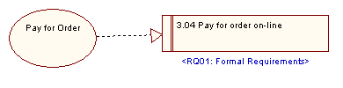
Implementation details for the Pay for Order use case
Figure 17 : Implementation

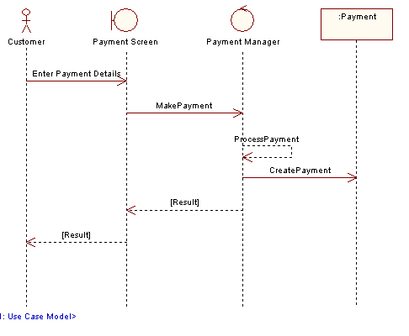
Pay for Order workflow
Figure 18 : Pay for Order

Remove Item from Cart
Use Case: A user may remove an item from their shopping cart. Once removed an item cannot be retrieved. The shopping cart will keep track of the current running total and update cart details when an item is removed.

Requirements
- Proposed. Remove item from cart.

Constraints
- Proposed Pre-condition . Cart must have exitising items.

Connections
- Used by actor Customer. A customer will use this use case to remove a previously added item from their shopping cart
- Realisation link to requirement 3.02 Remove titles from a shopping cart

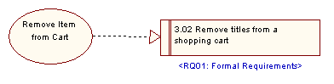
Remove Item from Cart traceability
Figure 19 : Implementation

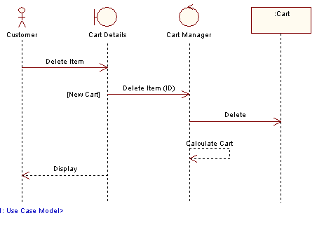
Illustrates the workflow associated with removing an item from the shopping cart
Figure 20 : Remove Item

View Cart
Use Case: This use case allows a user to view the contents of their current shopping cart.

Connections
- Used by actor Customer. A customer can view the contents of their cart
- Realisation link to requirement 3.03 View contents of shopping cart

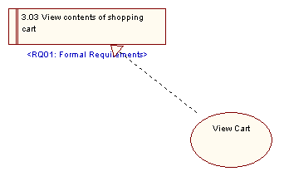

Figure 21 : Implementation

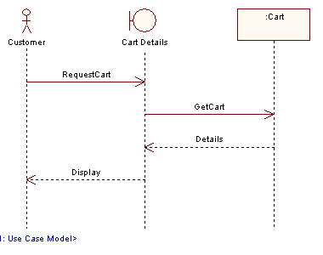

Figure 22 : View Cart

UC01-4: Order Status

The customer is able to view the status of their order on-line. They enter their order id and retrieve an updated report on status

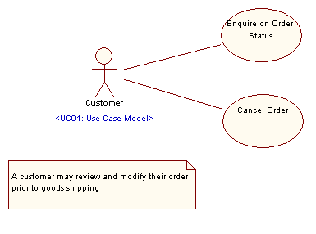
Figure 23 : Review Order Status

Cancel Order
Use Case: The suer logs onto the system and locates their orders. An order that has not been shipped and is not yet filled (that is, is on back order) may be cancelled by the user.

Requirements
- Proposed. List current orders.
- Proposed. Select Order.
- Proposed. Cancle order.

Constraints
- Proposed Invariant . Order must be on back order.
- Proposed Invariant . Order must not be shipped.

Connections
- Used by actor Customer. Under some circumstances a customer may cancel an order
- Realisation link to requirement 3.06 Cancel an Order

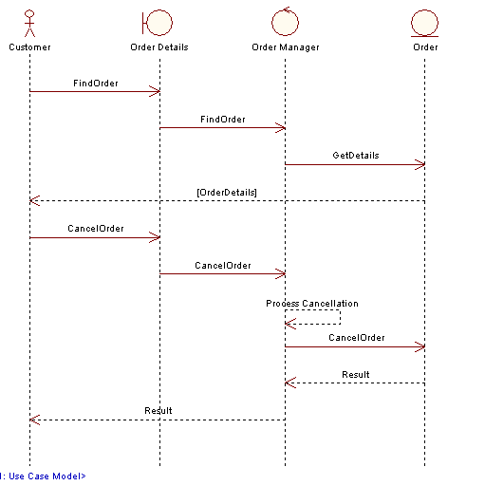
The flow of events when a user cancels an order. An order may only be cancelled prior to shipping.
Figure 24 : Cancel Order

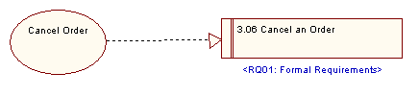
Cancel Order implmentation details
Figure 25 : Implementation

Enquire on Order Status
Use Case: The customer logs onto the system, then goes to the order status screen. From their they have a list of their current orders and the details of each order, including shipping status and back order status.

Requirements
- Proposed. View current orders.
- Proposed. Get shipping details on order.

Connections
- Used by actor Customer. A customer may enquire on their order status
- Realisation link to requirement 3.05 Query the shipping status of an order

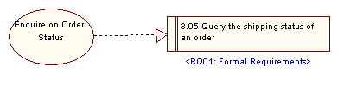
Order status traceability
Figure 26 : Implementation

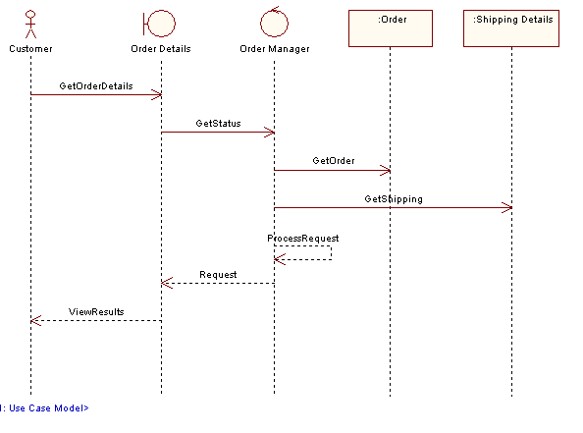
Current order status workflow
Figure 27 : Order Status

